**Case Study : Disease prediction with Symptoms Analysis**

**By :**

**Pandarge Nikhil N 1504012**

**Bhusnar Pradip S 1404037**

**Guided By:**

**Prof.Rankhambe J P**

**Code:**

#----------------------------

# Disease prediction with Symptoms analysis

# @author Nikhil N Pandarge

# @author Pradip S Bhusnar

#--------------------------

**code:**

getwd()

bc_data <- read.table("breast-cancer-wisconsin.data",

header = FALSE,

sep = ",")

head(bc_data)

colnames(bc_data) <- c("sample_code_number",

"clump_thickness",

"uniformity_of_cell_size",

"uniformity_of_cell_shape",

"marginal_adhesion",

"single_epithelial_cell_size",

"bare_nuclei",

"bland_chromatin",

"normal_nucleoli",

"mitosis",

"classes")

head(bc_data)

**Output:**

**> head(bc_data)**

**sample_code_number clump_thickness uniformity_of_cell_size uniformity_of_cell_shape**

**1 1000025 5 1 1**

**2 1002945 5 4 4**

**3 1015425 3 1 1**

**4 1016277 6 8 8**

**5 1017023 4 1 1**

**6 1017122 8 10 10**

**marginal_adhesion single_epithelial_cell_size bare_nuclei bland_chromatin normal_nucleoli**

**1 1 2 1 3 1**

**2 5 7 10 3 2**

**3 1 2 2 3 1**

**4 1 3 4 3 7**

**5 3 2 1 3 1**

**6 8 7 10 9 7**

**mitosis classes**

**1 1 2**

**2 1 2**

**3 1 2**

**4 1 2**

**5 1 2**

**6 1 4**

**Code:**

bc_data$classes <- ifelse(bc_data$classes == "2", "benign",

ifelse(bc_data$classes == "4", "malignant", NA))

bc_data[bc_data == "?"] <- NA

#how many NAs are in the data

length(which(is.na(bc_data)))

**Output:**

**16**

**Code:**

# how many samples would we loose, if we removed them?

nrow(bc_data)

**Output:**

**699**

**Code:**

nrow(bc_data[is.na(bc_data), ])

**Output:**

**16**

**Code:**

#--------------------------

# impute missing data

install.packages("mice")

library(mice)

bc_data[,2:10] <- apply(bc_data[, 2:10], 2, function(x) as.numeric(as.character(x)))

dataset_impute <- mice(bc_data[, 2:10], print = FALSE)

bc_data <- cbind(bc_data[, 11, drop = FALSE],

mice::complete(dataset_impute, 1))

bc_data$classes <- as.factor(bc_data$classes)

# How many benign and malignant cases are there?

summary(bc_data$classes)

**Output:**

**> summary(bc_data$classes)**

**benign malignant**

**458 241**

**Code:**

library(ggplot2)

ggplot(bc_data, aes(x = classes, fill = classes)) +

geom_bar()

**Output:**

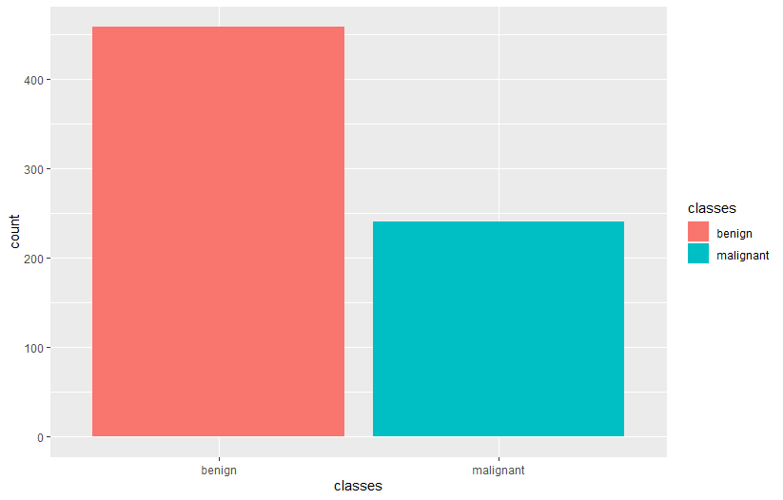

**Code:**

ggplot(bc_data, aes(x = clump_thickness)) +

geom_histogram(bins = 10)

**Output:**

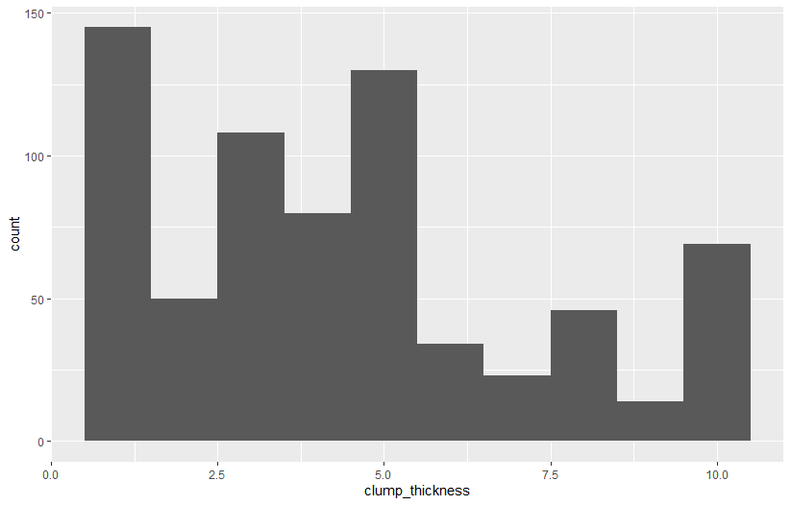

**Code:**

# principal component analysis:

if (!requireNamespace("BiocManager", quietly = TRUE))

install.packages("BiocManager")

BiocManager::install("pcaGoPromoter")

library(pcaGoPromoter)

library(ellipse)

# perform pca and extract scores

pcaOutput <- pca(t(bc_data[, -1]), printDropped = FALSE, scale = TRUE, center = TRUE)

pcaOutput2 <- as.data.frame(pcaOutput$scores)

# define groups for plotting

pcaOutput2$groups <- bc_data$classes

centroids <- aggregate(cbind(PC1, PC2) ~ groups, pcaOutput2, mean)

conf.rgn <- do.call(rbind, lapply(unique(pcaOutput2$groups), function(t)

data.frame(groups = as.character(t),

ellipse(cov(pcaOutput2[pcaOutput2$groups == t, 1:2]),

centre = as.matrix(centroids[centroids$groups == t, 2:3]),

level = 0.95),

stringsAsFactors = FALSE)))

ggplot(data = pcaOutput2, aes(x = PC1, y = PC2, group = groups, color = groups)) +

geom_polygon(data = conf.rgn, aes(fill = groups), alpha = 0.2) +

geom_point(size = 2, alpha = 0.6) +

scale_color_brewer(palette = "Set1") +

labs(color = "",

fill = "",

x = paste0("PC1: ", round(pcaOutput$pov[1], digits = 2) * 100, "% variance"),

y = paste0("PC2: ", round(pcaOutput$pov[2], digits = 2) * 100, "% variance"))

**Output:**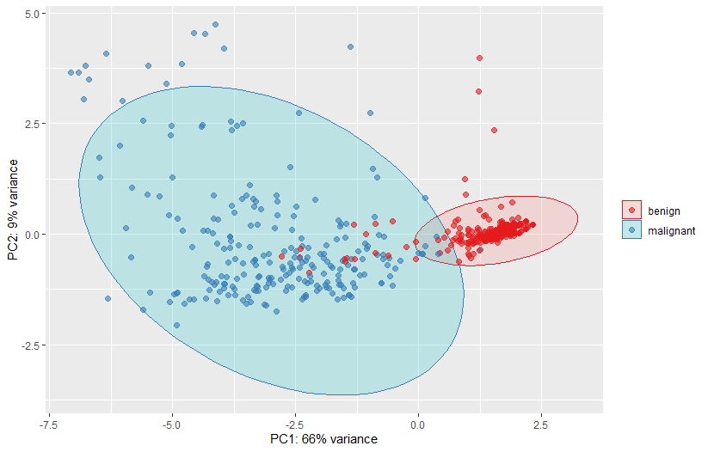

**code:**

library(tidyr)

gather(bc_data, x, y, clump_thickness:mitosis) %>%

ggplot(aes(x = y, color = classes, fill = classes)) +

geom_density(alpha = 0.3) +

facet_wrap( ~ x, scales = "free", ncol = 3)

**Output:**

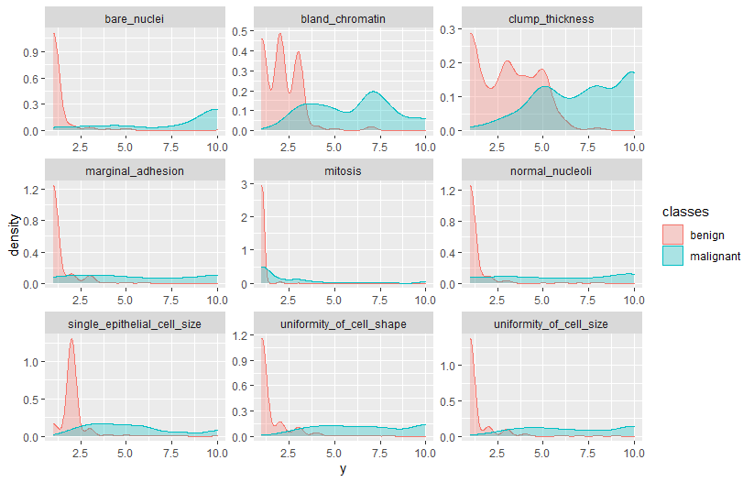

**Code:**

# configure multicore

install.packages("doParallel")

library(doParallel)

cl <- makeCluster(detectCores())

registerDoParallel(cl)

library(caret)

#Training, validation and test data

set.seed(42)

index <- createDataPartition(bc_data$classes, p = 0.7, list = FALSE)

train_data <- bc_data[index, ]

test_data <- bc_data[-index, ]

library(dplyr)

rbind(data.frame(group = "train", train_data),

data.frame(group = "test", test_data)) %>%

gather(x, y, clump_thickness:mitosis) %>%

ggplot(aes(x = y, color = group, fill = group)) +

geom_density(alpha = 0.3) +

facet_wrap( ~ x, scales = "free", ncol = 3)

**Output:**

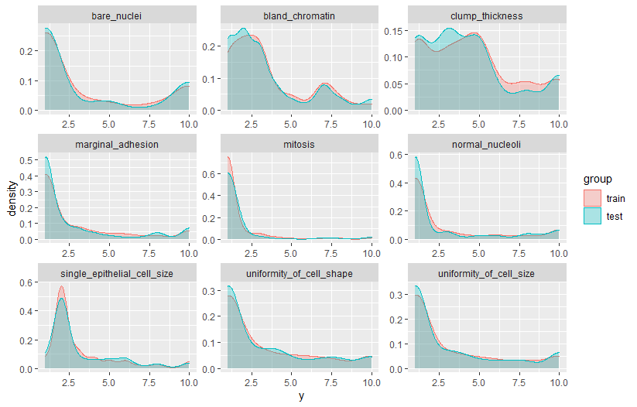

**Code:**

set.seed(42)

model_glm <- caret::train(clump_thickness ~ .,

data = train_data,

method = "glm",

preProcess = c("scale", "center"),

trControl = trainControl(method = "repeatedcv",

number = 10,

repeats = 10,

savePredictions = TRUE,

verboseIter = FALSE))

model_glm

predictions <- predict(model_glm, test_data)

**Output:**

**> model_glm**

**Generalized Linear Model**

**490 samples**

**9 predictor**

**Pre-processing: scaled (9), centered (9)**

**Resampling: Cross-Validated (10 fold, repeated 10 times)**

**Summary of sample sizes: 442, 440, 443, 442, 441, 441, ...**

**Resampling results:**

**RMSE Rsquared MAE**

**1.951781 0.5273127 1.62851**

**Code:**

predictions <- predict(model_glm, test_data)

# model_glm$finalModel$linear.predictors == model_glm$finalModel$fitted.values

# residual is the difference between observed value and predicted value.

data.frame(residuals = resid(model_glm),

predictors = model_glm$finalModel$linear.predictors) %>%

ggplot(aes(x = predictors, y = residuals)) +

geom_jitter() +

geom_smooth(method = "lm")

**Output:**

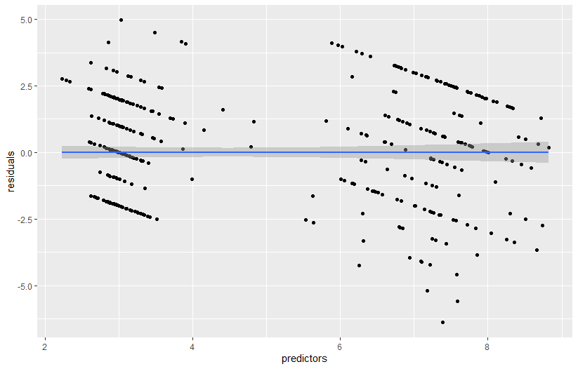

**Code:**

# y == train_data$clump_thickness:

data.frame(residuals = resid(model_glm),

y = model_glm$finalModel$y) %>%

ggplot(aes(x = y, y = residuals)) +

geom_jitter() +

geom_smooth(method = "lm")

**Output:**

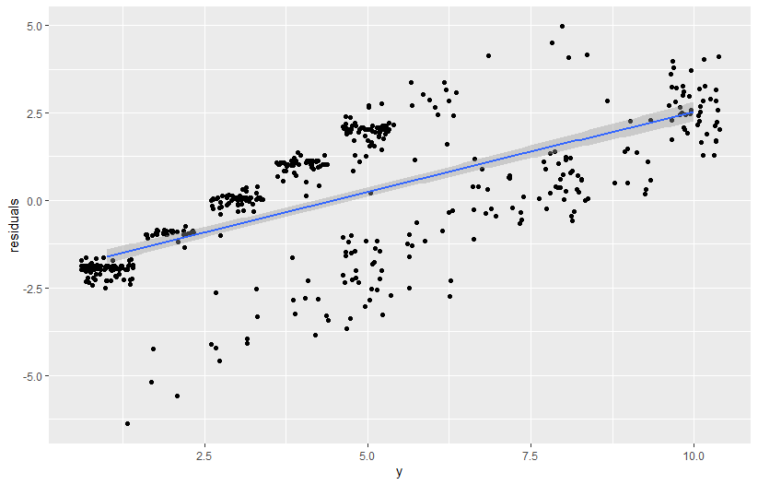

**Code:**

#Classification:

library(rpart)

library(rpart.plot)

set.seed(42)

fit <- rpart(classes ~ .,

data = train_data,

method = "class",

control = rpart.control(xval = 10,

minbucket = 2,

cp = 0),

parms = list(split = "information"))

rpart.plot(fit, extra = 100)

**Output:**

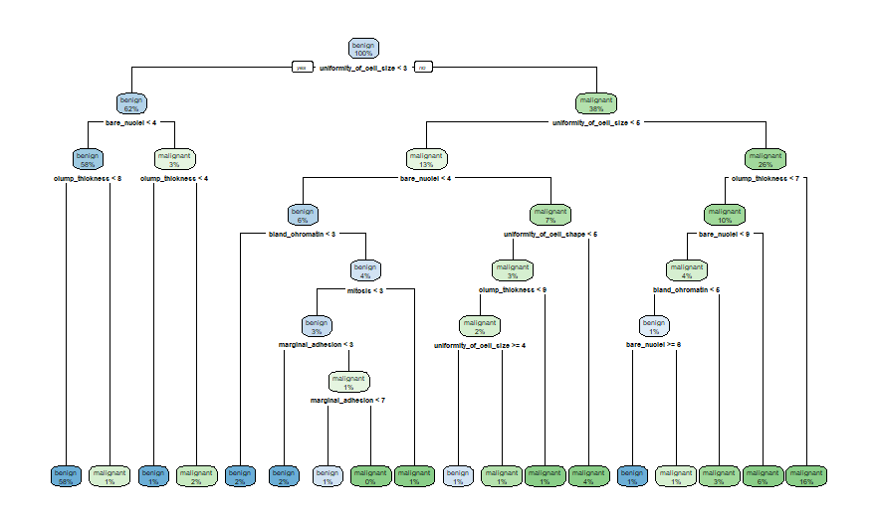

**Code:**

#rain forest

set.seed(42)

model_rf <- caret::train(classes ~ .,

data = train_data,

method = "rf",

preProcess = c("scale", "center"),

trControl = trainControl(method = "repeatedcv",

number = 10,

repeats = 10,

savePredictions = TRUE,

verboseIter = FALSE))

model_rf$finalModel$confusion

imp <- model_rf$finalModel$importance

imp[order(imp, decreasing = TRUE), ]

**Output:**

**> model_rf$finalModel$confusion**

**benign malignant class.error**

**benign 310 11 0.03426791**

**malignant 6 163 0.03550296**

**> imp <- model_rf$finalModel$importance**

**> imp[order(imp, decreasing = TRUE), ]**

**bare_nuclei uniformity_of_cell_size uniformity_of_cell_shape**

**43.079030 38.388266 36.212991**

**bland_chromatin normal_nucleoli single_epithelial_cell_size**

**28.917296 20.936824 19.624624**

**clump_thickness marginal_adhesion mitosis**

**17.791695 11.687941 2.961946**

**Code:**

# estimate variable importance

importance <- varImp(model_rf, scale = TRUE)

plot(importance)

**Output:**

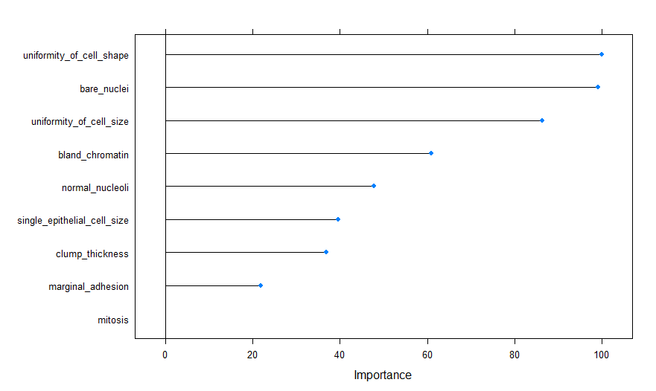

**Code:**

confusionMatrix(predict(model_rf, test_data), test_data$classes)

**Output:**

**> confusionMatrix(predict(model_rf, test_data), test_data$classes)**

**Confusion Matrix and Statistics**

**Reference**

**Prediction benign malignant**

**benign 135 2**

**malignant 2 70**

**Accuracy : 0.9809**

**95% CI : (0.9517, 0.9948)**

**No Information Rate : 0.6555**

**P-Value [Acc > NIR] : <2e-16**

**Kappa : 0.9576**

**Mcnemar's Test P-Value : 1**

**Sensitivity : 0.9854**

**Specificity : 0.9722**

**Pos Pred Value : 0.9854**

**Neg Pred Value : 0.9722**

**Prevalence : 0.6555**

**Detection Rate : 0.6459**

**Detection Prevalence : 0.6555**

**Balanced Accuracy : 0.9788**

**'Positive' Class : benign**

**Code:**

results <- data.frame(actual = test_data$classes,

predict(model_rf, test_data, type = "prob"))

results$prediction <- ifelse(results$benign > 0.5, "benign",

ifelse(results$malignant > 0.5, "malignant", NA))

results$correct <- ifelse(results$actual == results$prediction, TRUE, FALSE)

ggplot(results, aes(x = prediction, fill = correct)) +

geom_bar(position = "dodge")

**Output:**

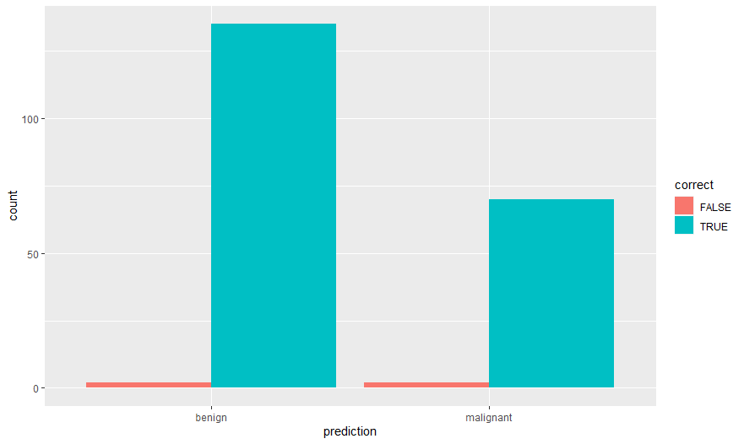

**Code:**

ggplot(results, aes(x = prediction, y = benign, color = correct, shape = correct)) +

geom_jitter(size = 3, alpha = 0.6)

**Output:**

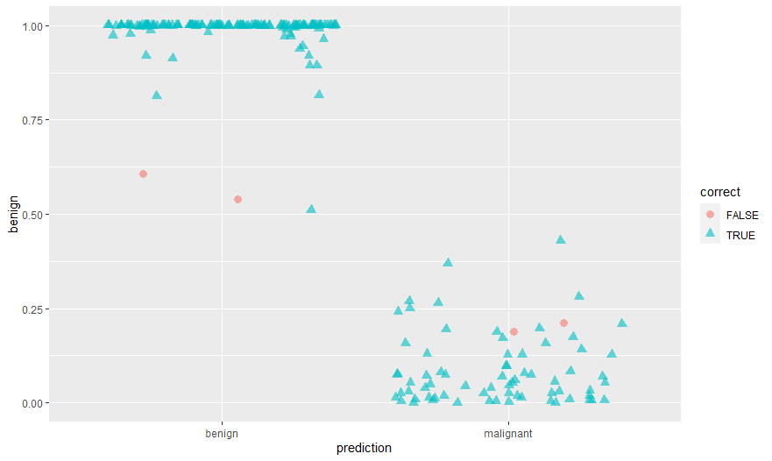

**Code:**

#Feature Selection:

library(corrplot)

# calculate correlation matrix

corMatMy <- cor(train_data[, -1])

corrplot(corMatMy, order = "hclust")

**Output:**

